# Computing regression parameters (gradient descent example)

## The data

Consider the following 5 point synthetic data set:

X Y

0 1

1 3

2 7

3 13

4 21

Which is plotted below:

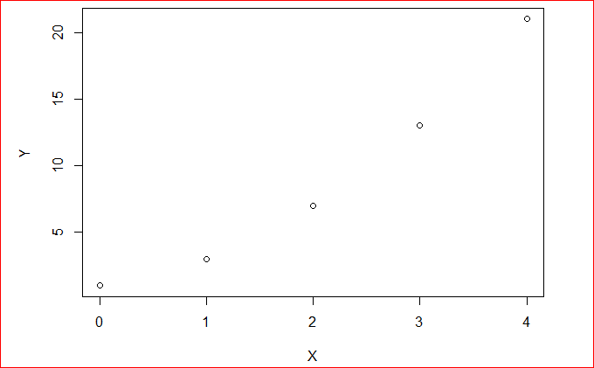

## What we need

Now that we’ve computed the regression line using a closed form solution let’s do it again but with gradient descent.

Recall that:

* The derivative of the cost for the intercept is the sum of the errors
* The derivative of the cost for the slope is the sum of the product of the errors and the input

We will need a starting value for the slope and intercept, a step_size and a tolerance

* initial_intercept = 0
* initial_slope = 0
* step_size = 0.05
* tolerance = 0.01

## The algorithm

In each step of the gradient descent we will do the following:

1. Compute the predicted values given the current slope and intercept **Y = mX + c**

2. Compute the prediction errors (prediction - Y) **Yi - Y**

3. Update the intercept:

* compute the derivative: sum(errors) **Sigma(Yi - Y)**
* compute the adjustment as step_size times the derivative **Eta*(Sigma(Yi - Y))**
* decrease the intercept by the adjustment **W0t - Eta*(Sigma(Yi - Y))**

4. Update the slope:

* compute the derivative: sum(errors*input) **(Sigma(Yi - Y))Xi)**
* compute the adjustment as step_size times the derivative **Eta** * **(Sigma(Yi - Y))Xi)**
* decrease the slope by the adjustment **W1t - (Sigma(Yi - Y))Xi)**

5. Compute the magnitude of the gradient

6. Check for convergence

## The algorithm in action

****First step:****

Intercept = 0

Slope = 0

1. predictions = [0, 0, 0, 0, 0]

2. errors = [-1, -3, -7, -13, -21]

3. update Intercept

* sum([-1, -3, -7, -13, -21]) = -45
* adjustment = 0.05 * 45 = -2.25
* new_intercept = 0 - -2.25 = 2.25

4. update Slope

* sum([0, 1, 2, 3, 4] * [-1, -3, -7, -13, -21]) = -140
* adjustment = 0.05 * 45 = -7
* new_slope = 0 - -7 = 7

5. magnitude = sqrt(( -45)^2 + (-140)^2) = 147.05

6. magnitude > tolerance: not converged

****Second step:****

Intercept = 2.25

Slope = 7

1. predictions = [2.25, 9.25, 16.25, 23.25, 30.25]

2. errors = [1.25, 6.35, 9.25, 10.25, 9.25]

3. update Intercept

* sum([1.25, 6.35, 9.25, 10.25, 9.25]) = 36.25
* adjustment = 0.05 * 36.25 = 1.8125
* new_intercept = 2.25-1.8125 = 0.4375

4. update Slope

* sum([0, 1, 2, 3, 4] * [1.25, 6.35, 9.25, 10.25, 9.25]) = 92.5
* adjustment = 0.05 * 92.5 = 4.625
* new_slope = 7 - 4.625 = 2.375

5. magnitude = sqrt((36.25)^2 + (92.5)^2) = 99.35

6. magnitude > tolerance: not converged

****Third step:****

Intercept = 0.4375

Slope = 2.375

1. predictions = [0.4375, 2.8125, 5.1875, 7.5625, 9.9375]

2. errors = [-0.5625, -0.1875, -1.8125, -5.4375, -11.0625]

3. update Intercept

* sum([-0.5625, -0.1875, -1.8125, -5.4375, -11.0625]) = -19.0625
* adjustment = 0.05 * = -0.953125
* new_intercept = 0.4375 - -0.953125 = 1.390625

4. update Slope

* sum( [0, 1, 2, 3, 4] * [-0.5625, -0.1875, -1.8125, -5.4375, -11.0625]) = -64.375
* adjustment = 0.05 * -64.375= -3.21875
* new_slope = 2.375 --3.21875 = 5.59375

5. magnitude = sqrt(( -19.0625)^2 + (-64.375)^2) = 67.13806

6. magnitude > tolerance: not converged

Let’s skip forward a few steps… after the 77th step we have gradient magnitude 0.0107.

****78th Step:****

Intercept = -0.9937

Slope = 4.9978

1. predictions = [-0.99374, 4.00406, 9.00187, 13.99967, 18.99748]

2. errors = [-1.99374, 1.00406, 2.00187, 0.99967, -2.00252]

3. update Intercept

* sum([-1.99374, 1.00406, 2.00187, 0.99967, -2.00252]) = 0.009341224
* adjustment = 0.05 * 0.009341224 = 0.0004670612
* new_intercept = -0.9937 - 0.0004670612 = -0.994207

4. update Slope

* sum([0, 1, 2, 3, 4] * [-1.99374, 1.00406, 2.00187, 0.99967, -2.00252]) = -0.0032767
* adjustment = 0.05 *-0.0032767 = -0.00016383
* new_slope = 4.9978 --0.00016383 = 4.9979

5. magnitude = sqrt[()^2 + ()^2] = 0.0098992

6. magnitude < tolerance: converged!

****Final slope: -0.994****

****Final Intercept: 4.998****

If you continue you will get to (-1, 5) but at this point the change in RSS (our cost) is negligible.

## Visualizing the steps:

After the first step we have this line:

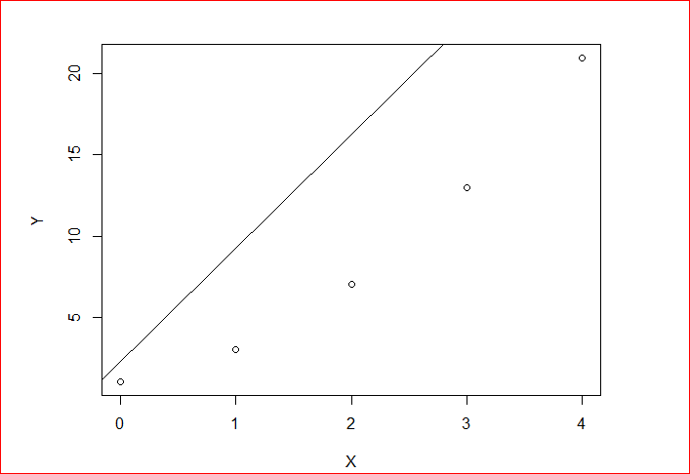

After the second step we have this line:

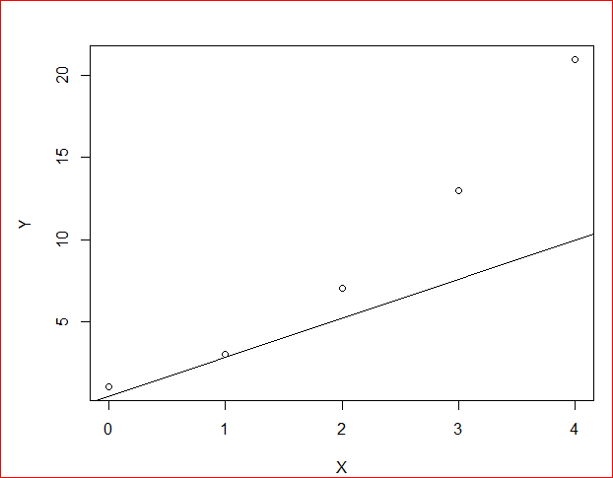

After the third step we have this line:

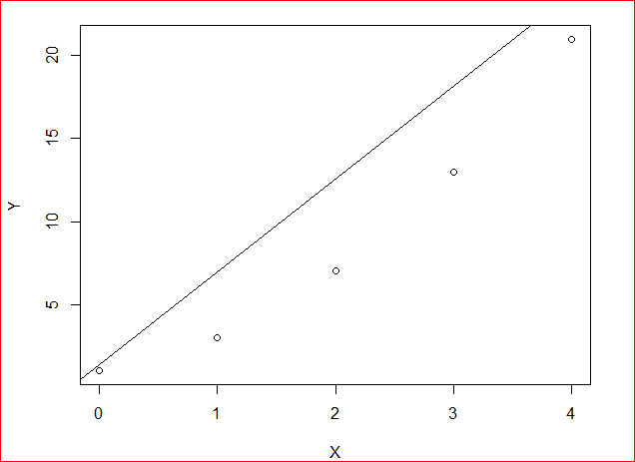

And after the final step we have this line:

